**Classification**

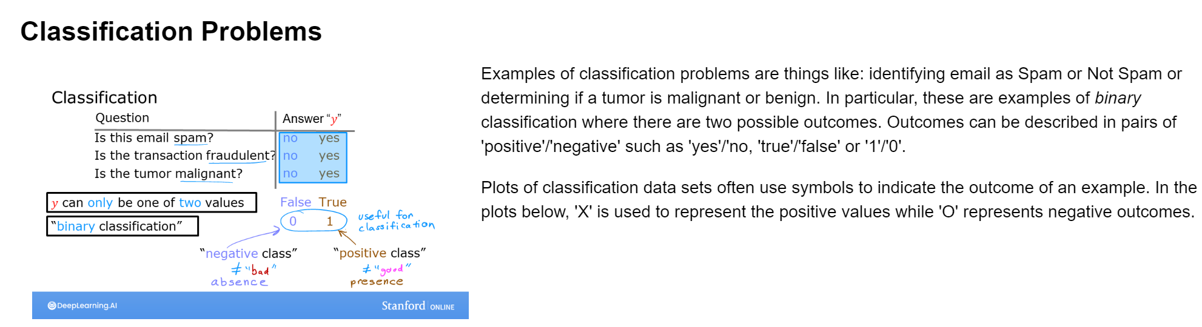

Figure 1 Classifications problems

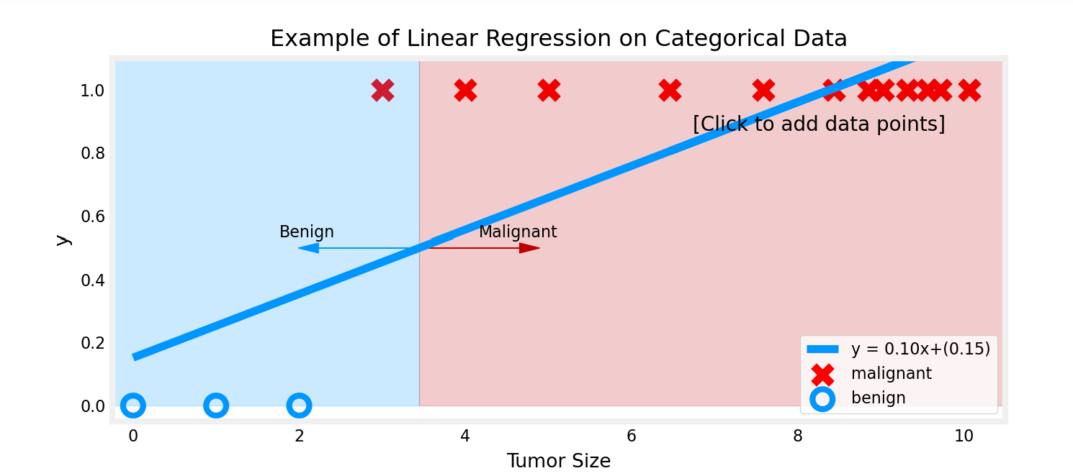

The example above demonstrates that the linear model is insufficient to model categorical data.

**Logistic regression**

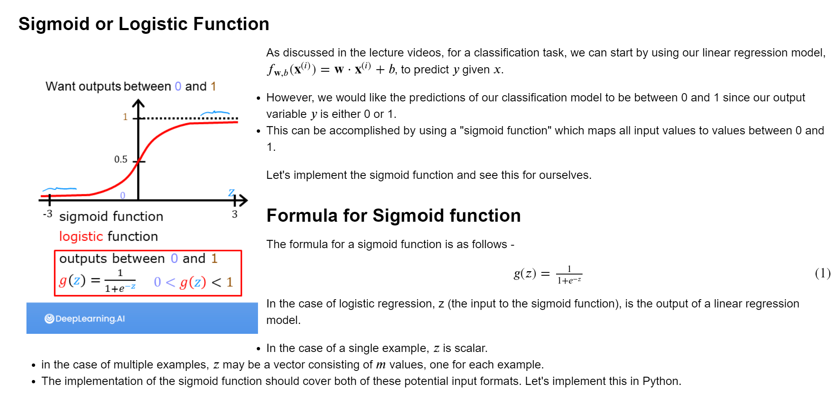

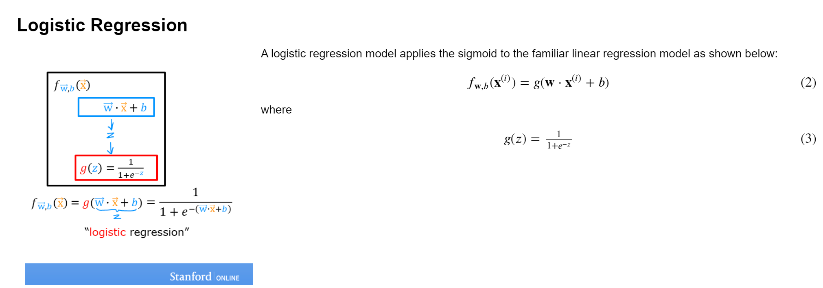

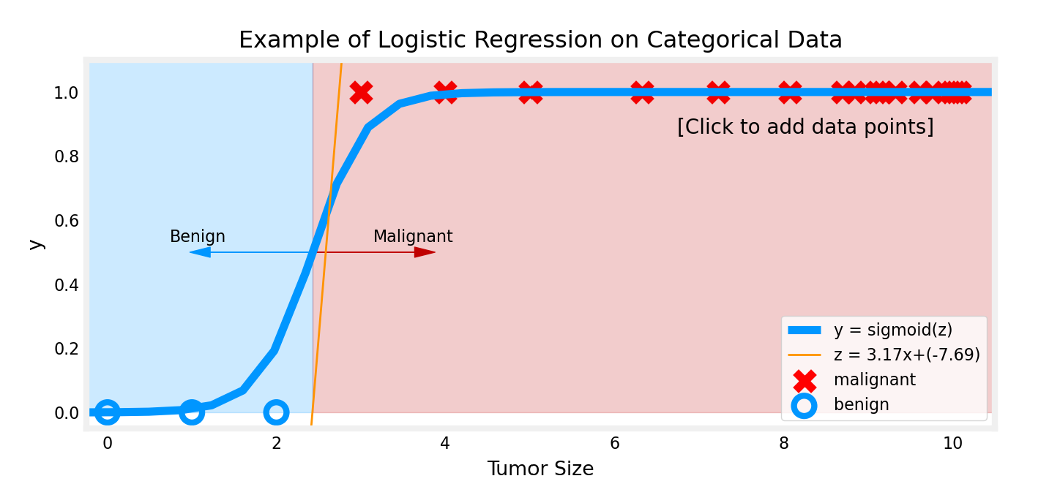

Unlike linear regression, when big tumor size examples are added, the model still make correct prediction.